Label each structure of the following pairs as superior (S) or inferior (I).

Neck | _______ | Vs. | Nose | _______
Abdomen | _______ | Vs. | Chest | _______
Chin | _______ | Vs. | Eye | _______
Abdomen | _______ | Vs. | Thigh | _______
Mouth | _______ | Vs. | Nose | _______

Label each of the following pairs as anterior (A) or posterior (P).

Knee cap _______ Vs. Popliteal region _______
Knuckles _______ Vs. Palm _______
Heel _______ Vs. Toe _______
Breastbone _______ Vs. Shoulder blade _______
Breastbone _______ Vs. Heart _______
Label each member of the following pairs as proximal (P) or distal (D).

Fingers | _______ | Vs. | Wrist | _______
Forearm | _______ | Vs. | Wrist | _______
Upper arm | _______ | Vs. | Forearm | _______
Calf | _______ | Vs. | Thigh | _______
Calf | _______ | Vs. | Toes | _______
Label each of the following pairs as medial (M) or lateral (L). Use either the skeleton or a diagram of the skeleton as an aid.

Forearm – radius _______ Vs. Forearm – ulna bone _______
(thumb side) (little finger side)
Calf – fibula bone_______ Vs. Calf – tibia bone _______
(thinner bone) (thicker bone)
Thumb _______ Vs. Index finger _______
Big toe _______ Vs. Smallest toe _______
Index finger _______ Vs. Little finger _______

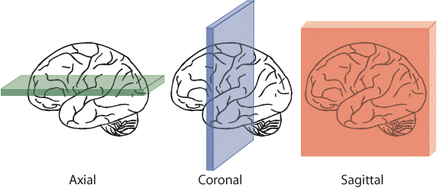
Exercise 2: Body Sections and Planes

Below are sections of a brain. Identify the plane used to create each image.
Figure 2
Figure 3
Figure 4
2.

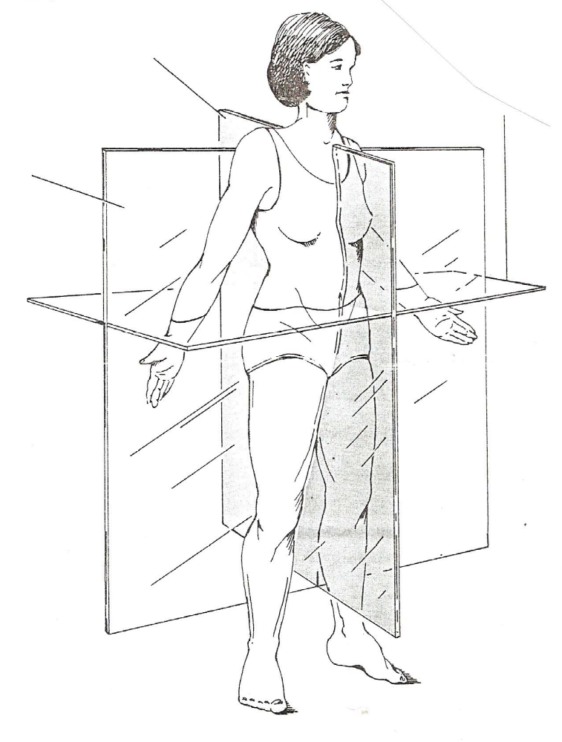
Figure 5
Label the body planes shown in figure 5.

Exercise 3: Body Cavities
Label the body cavities shown in figure 6. Number 5 is what divides cavity 1 from cavity 2.
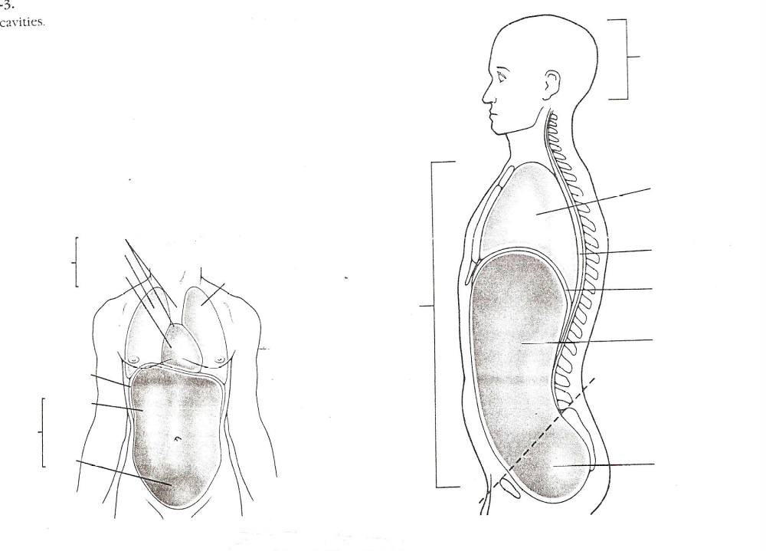
1.
9.
2.
3.
4.
5.
6.
8.
7.
Figure 6
1. ________________________________________
2. ________________________________________
3. ________________________________________
4. ________________________________________
5. ________________________________________
6. ________________________________________
7. ________________________________________
8. ________________________________________
9. ________________________________________

3.

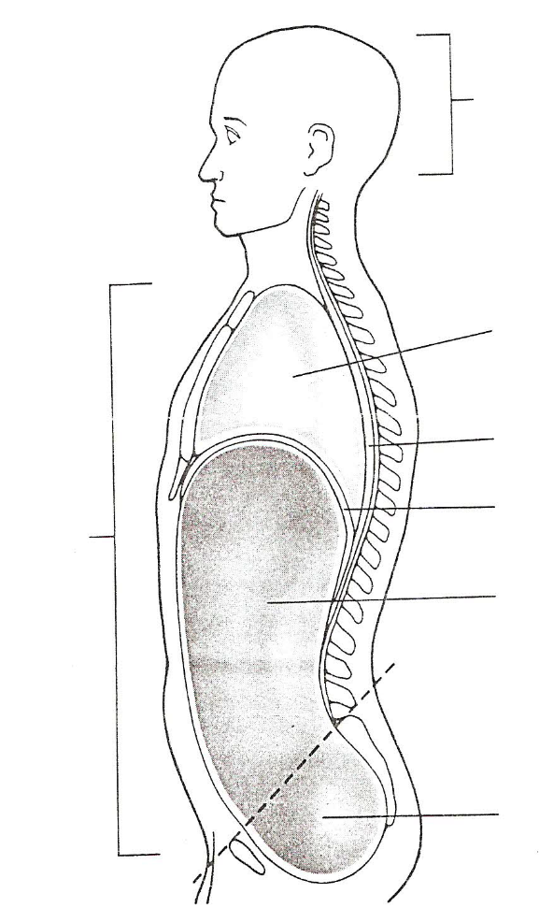
Figure 7
Write the correct name next to the leader line for each of the body cavities shown in the figure 7.

What does the dotted line in figure 7 represent? _________________________________________________________

__________________________________________________________________________________________________

List the main body cavity (dorsal or ventral) and the subcavity (abdominal, cranial, pelvic, spinal, or thoracic) containing each of the following body organs.

Body Organ | Main Cavity | Subcavity
Brain | ______________________ | ____________________________
Lung | ______________________ | ____________________________
Bladder | ______________________ | ____________________________
Heart | ______________________ | ____________________________
Stomach | ______________________ | ____________________________
Liver | ______________________ | ____________________________
Spinal cord | ______________________ | ____________________________
Ovary | ______________________ | ____________________________
Esophagus | ______________________ | ____________________________
Spleen | ______________________ | ____________________________  4.
Pancreas | ______________________ | ____________________________
Uterus | ______________________ | ____________________________
Gall bladder | ______________________ | ____________________________
Small intestine | ______________________ | ____________________________

Exercise 4: Regional Terms
Write the regional term next to the line extending from each overall body region.

Figure 8
Figure 9

List the correct regional term next to each of the following descriptions of localized body regions.

Chest | ____________________ |  | Forearm | ____________________
Anterior torso below diaphragm | ____________________ |  | Root of thigh between lower extremity and abdomen | ____________________
Rib | ____________________ |  | Lower back between ribs and pelvis | ____________________
Buttocks | ____________________ |  | Armpit | ____________________
Upper arm | ____________________ |  | Posterior elbow | ____________________
Upper leg | ____________________ |  | Lower leg | ____________________
Depression posterior to kneecap | ____________________ |  | Sole of foot | ____________________
Anterior elbow | ____________________ |  | Neck | ____________________
5.

Name: _______________________________________________ Date:_________________ Class:________

Anatomy – Its Organization and Terminology Lab Report

Exercise 1: Directional Terms
In the box to the right:
- Draw a person in the anatomical position showing the position of the face, arms, palms of hands, thumbs, and legs. You may use a stick figure.
- Next use your red color pencils to draw the midline.
- Finally, label the anatomical left and right side.
Label the directional terms in the figure below by writing the correct terms along the arrows.

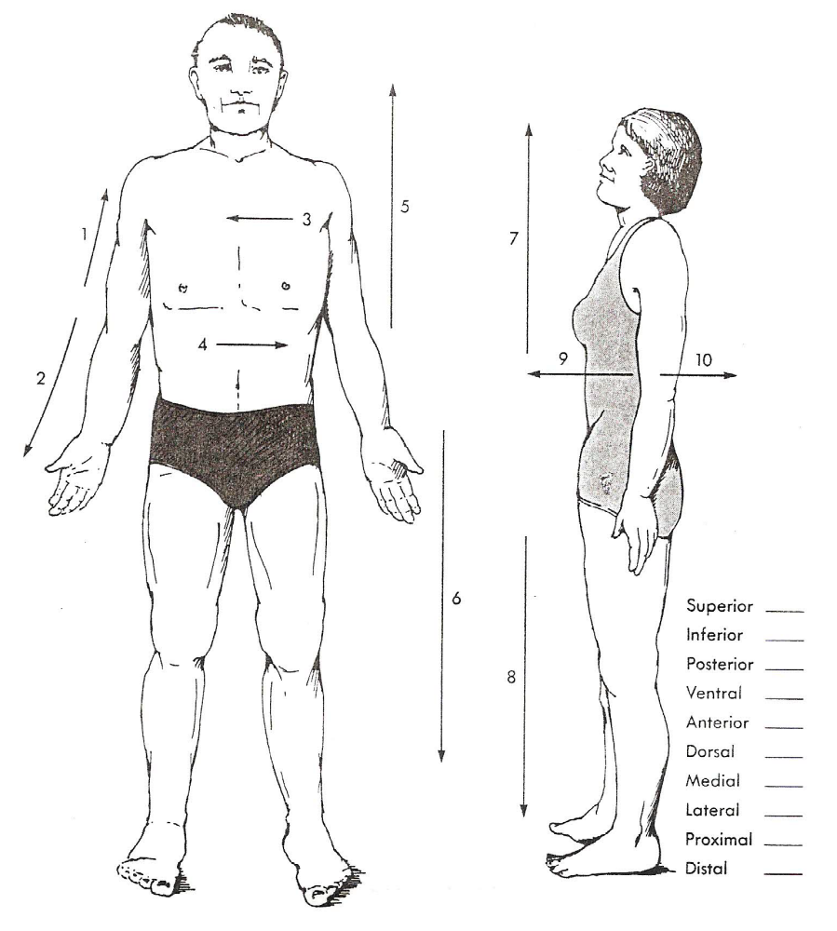
Figure 1
Write the directional term has the opposite meaning to the terms below.
Superior ___________________
Inferior ___________________
Posterior ___________________
Ventral ___________________
Anterior ___________________
Dorsal ___________________
Medial ___________________
Lateral ___________________
Proximal ___________________
Distal ___________________
1.

